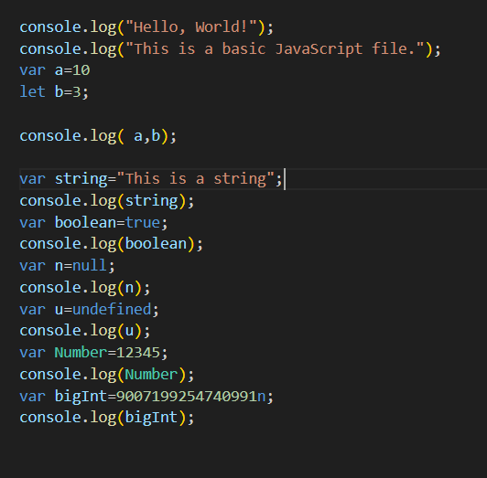
Fig:Code
Today I practisec about html variables like var and let .And then I practised about javaScript datatypes like Number,String,Boolean,bigInt,Number .In the above image I insert the image that I practised

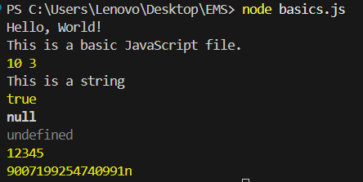
Fig:Output
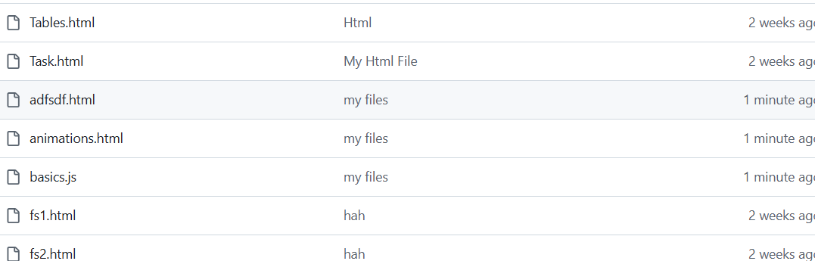
Fig:Repo

